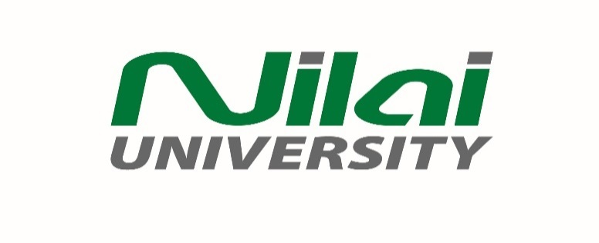

**MASTER OF BUSINESS ADMINISTRATION**

**BANKING & FINANCE/MANAGEMENT//MARKETING**

**FINAL EXAMINATION**

**MAY 2024**

**Cou**rse: OBM4406 Duration to complete: 3 hours

(Research Methodology) Start time: 2.00 pm; 8/9/2024

Lecturer: Dr. Gan Joo Kong End time: 5.00 pm; 8/9/2024

**INSTRUCTIONS:**

1. Answer **ALL** questions. Each question carries **25 marks**.

2. The mark allocated for this paper is **100** but it constitutes **30%** to the total mark.

3. This examination paper is confidential. The questions must be answered individually.

You are not permitted to discuss or consult with other students or individuals.

4. References must be made if you use any reference materials.

**Answer Format:**

1. Type your answers in the space provided in the online examination.
2. You may answer in Ms Word document and submit as an attachment if the space provided is insufficient.

This exam paper consists of **ONE (1)** printed page (excluding the front cover)

**OBM4406 (Research Methodology)**

**Final Exam May 2024**

Answer **ALL** questions. Each question carries **25 marks**.

1. a. Explain the **four (4)** characteristics of a research topic. (20 marks)

b. Identify the purpose of a quantitative research. (5 marks)

2. a. Explain the quantitative approach you would adopt based on

your research topic. (15 marks)

b. From the research approach you have adopted, explain the

research strategy is identified to collect the data. (10 marks)

3. a. Explain the use of literature review to ascertain the development

of the appropriate association between the independent variables

and the dependent variable. (12 marks)

b. Justify the importance of sample size in quantitative research. (13 marks)

4. a. Explain **two (2)** differences between quantitative research and

qualitative research. (12 marks)

b. Explain in **four (4)** ways the usefulness of literature review to

a researcher. (13 marks)

......................................... END OF QUESTION PAPER .....................

.