|  |
| --- |
| **Topic 2: Demand** |

* 1. **Demand**

1. Demand: Functional relationship between the price and quantity demanded of goods and services by consumers in a given period of time, all else held constant.
2. Non-price factors influence demand, causing either an increase or a decrease in demand. These factors are the following.
3. Tastes and Preferences
4. A favorable change in the taste for good X increases its demand.
5. Income
6. Normal Good: A product whose demand will increase with an increase in income.
7. Inferior Good: A product whose demand will decrease with an increase in income.
8. Prices of Related Goods
9. Substitute Goods: Products that can be used in place of one another. An increase in the price of a substitute good, Y, causes an increase in the demand for good X.
10. Complementary Goods: Products that are used together. A decrease in the price of a complementary good, Y, causes an increase in the demand for good X.
    * 1. Future Expectations
         1. An expected increase in the future price of good X will increase its current demand.
         2. This was demonstrated in the world grain prices in 2007 and in steel prices in 2011.
      2. Number of Consumers
    1. Demand Curve: The graphical relationship between the price of a good (P) and the quantity demanded by consumers (Q), with all other factors influencing demand held constant.

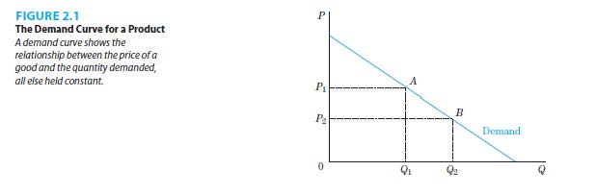

* + 1. Demand Shifters: The variables in a demand function that are held constant when defining a given demand curve. If their values change, the demand curve would shift.
    2. Price is on the vertical axis and quantity demanded is on the horizontal axis.
    3. Demand curves are generally downward sloping.
    4. Price and quantity demanded have a negative relationship.
  1. Change in Quantity Demanded and Change in Demand
     1. Change in Quantity Demanded: Movement along a demand curve when consumers react to a change in the price of the product, all other factors held constant. This is illustrated in Figure 2.1.
     2. Change in Demand: Movement of the entire demand curve when consumers react to a change in factors other than the price of the product changing. This is illustrated in Figure 2.2.

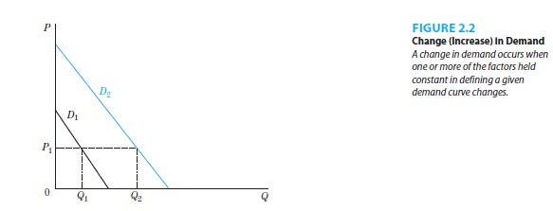

* 1. The market demand curve can be derived by horizontal summation of the individual demand curves.
     1. Horizontal Summation: For every price, add the quantity that each individual in a market demands.
     2. A simple example is when there are two individuals in a market. This is illustrated in Figure 2.3.

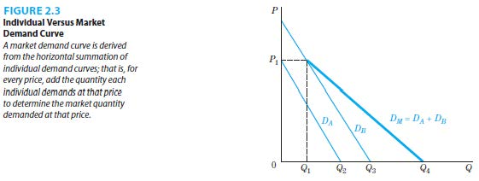

* 1. Linear Demand Function and Curves
     1. Linear Demand Function: Mathematical relationship in which all terms are added or subtracted.
     2. The graph of a linear demand curve is a straight line.

|  |
| --- |
| **References** |

Mankiw, N. Gregory. *Principles of economics*. Cengage Learning, 2018.

Farnham, P.G. 2013. *Economics for Managers*. 3rd edn. United States of America: Prentice Hall.