|  |
| --- |
| **Topic 6: Market Structure: Monopolistic Competition** |

* 1. **Monopolistic Competition**

1. Monopolistic Competition: A market structure characterized by a large number of small firms which have some market power from producing differentiated products. This market power can be competed away over time.
2. Monopolistic competition lies on the end of the competitive spectrum, close to the model of perfect competition. However, the model incorporates elements of both the perfectly competitive and monopoly models.
3. Assumptions of Monopolistic Competition
4. Product differentiation exits among firms. These include the range and type of offerings of the product as well as geographic location.
5. There are a large number of firms in the product group.
6. No interdependence exists among firms.
7. Entry by new firms is relatively easy.
8. Short-Run and Long-Run Models of Monopolistic Competition
9. The short-run model and long-run models of monopolistic competition are presented in Figures 8.4a and 8.4b.

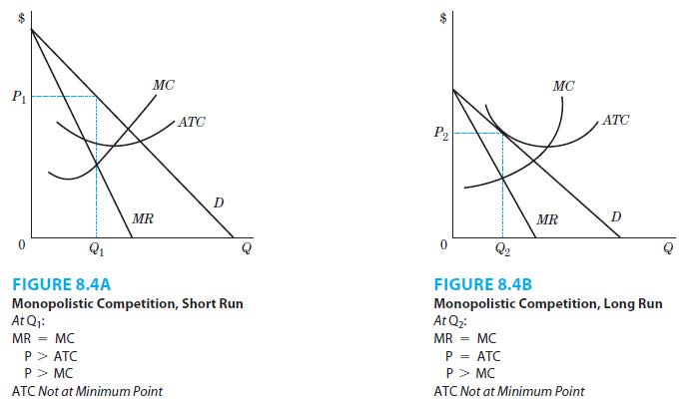

1. Figure 8.4a is similar to the monopoly model in Figure 8.1.
2. The monopolistically competitive firm also faces a downward sloping demand curve. However, the demand is more elastic than for the monopolist given the larger number of substitutes.
3. The monopolistically competitive firm produces the profit-maximizing level of output where marginal revenue equals marginal cost and charges the price read off the demand curve.
4. The firm typically earns positive profits in the short-run because product differentiation and geographic location give the firm market power.
5. Since entry is relatively easy, short-run positive profits cannot be sustained in the long-run.
6. Other firms will produce the same or similar products, making the demand curve to become more elastic. This results in zero economic profit in long-run equilibrium as positive profits are competed away.
7. Managers of monopolistically competitive firms must continue to search for strategies that give them at least temporary market power.
8. These strategies include product differentiation, seeking out market niches, geographic location, and advertising. These firms have an incentive to advertise their product.
9. Examples of Monopolistically Competitive Behavior
10. Small drugstores have been able to compete against the large chains by cutting prices down to cost on some of their drugs to match the lower chain prices achieved through economies of scale.
11. Small hardware stores have followed similar strategies to compete with chains stores by offering personal service and convenience. In addition, these stores have geographic market power.
12. Small bookstores have developed market power through steep discounts on books, aggressive marketing, and accessible locations in strip malls.

|  |
| --- |
| **References** |

Mankiw, N. Gregory. *Principles of economics*. Cengage Learning, 2018.

Farnham, P.G. 2013. *Economics for Managers*. 3rd edn. United States of America: Prentice Hall.