SELF-CHECK 4
Table 1

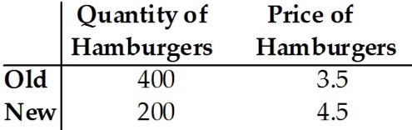

1) Refer to Table 1. A change in the price of hamburgers caused the change in quantity demanded shown in the table. The price elasticity of demand for hamburgers (calculated using the initial value formula) is: __________

Table 2

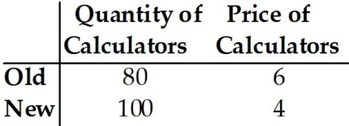

2) Refer to Table 2. A change in the price of calculators caused the change in quantity demanded shown in the table. The price elasticity of demand for calculators, using the initial-value formula, is: ____________

Table 3

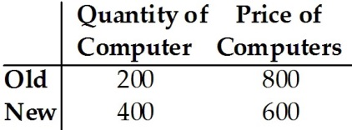

3) Refer to Table 3. A change in the price of computers caused the change in quantity demanded shown in the table. The price elasticity of demand (calculated using the initial value formula) is: ___________

