|  |
| --- |
| **Topic 5: Market Structure: Perfect Competition** |

* 1. **The Model of Perfect Competition**
  2. The assumptions of perfect competition are:
     1. a large number of firms in the market;
     2. an undifferentiated product;
     3. ease of entry into the market or no barriers to entry; and
     4. complete information available to all market participants.
  3. Perfectly competitive firms are price-takers.
     1. Price-Taker: A characteristic of a perfectly competitive market in which a firm cannot influence the price of its product but can sell any amount of output at the market established price.
  4. Table 7.1 contrasts the four market structures and presents an easy teaching tool for comparing the characteristics of the four market environments.

* 1. Model of the Industry or Market and the Firm
     1. The market demand and supply determine market price of the good (and the market quantity of output).

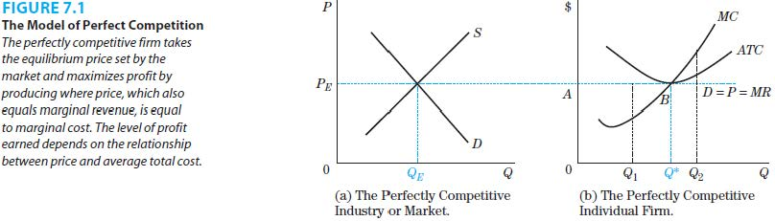

* + 1. The demand curve facing an individual firm is perfectly elastic or horizontal at the market determined price. This constitutes price-taking.



* + 1. The output produced by a competitive firm depends on the goal of the firm, profit maximization.
       1. Profit Maximization: The assumed goal of firms, which is to develop strategies to earn the largest amount of profits possible. This can be accomplished by focusing on either revenues or costs or both factors.
       2. Equation 7.1: = TR-TC

where = Profit

TR= Total Revenue

TC=Total Cost

* + - 1. Profit Maximization Rule: To maximize profits, a firm should produce the level of output where marginal revenue equals marginal cost.
      2. Equation 7.2: Produce the level of output where MR=MC

where MR= Marginal Revenue= (∆TR/∆Q)

where MC= Marginal Cost= = (∆TC/∆Q)

* + 1. Given that a perfectly competitive firm faces a horizontal demand, the price and marginal revenue are the same. This is only true for firms with no market power (facing a horizontal demand). A price-taking firm does not need to lower the price to sell one more unit of output, making the revenue change equal the price.
    2. If MR=MC, then the firm produces the optimal output level, Q*. At this level of output, profits can be positive, negative or zero.
    3. An alternative method of calculating profit is the per-unit profit, (P-ATC), multiplied by the quantity, Q.
    4. Even if the firm is producing the output where MR=MC, it should stop producing and shut down if the price is below AVC, i.e. it cannot cover its variable cost.
       1. Shut-Down Point: The price, which just equals the firm’s average variable cost, below which it is more profitable for the perfectly competitive firm to shut down than to continue to produce it.
    5. The supply curve for the perfectly competitive firm is the portion of the marginal cost curve that lies above the minimum average variable cost.

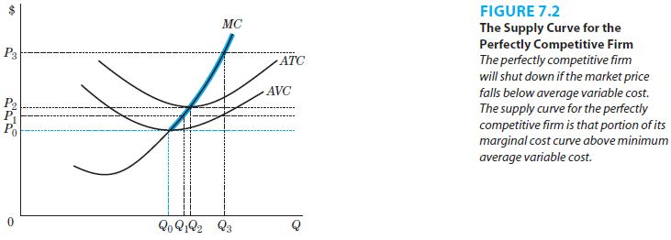

* + 1. The supply curve for the perfectly competitive industry or market is upward sloping.
  1. The Short Run in Perfect Competition
     1. The firm cannot change the scale of operation in the short run since at least one input is fixed.
     2. Firms cannot enter or exit the industry in the short run.
     3. Where P=MR=MC, the firm can be earning positive, negative or zero profits. If the price is below the average variable cost, the firm shuts down.

* 1. Long-Run Adjustment in Perfect Competition: Entry and Exit
     1. Entry and exit by new and existing firms and changes in the scale of operation by all firms can occur in the long run.
     2. Equilibrium Point: The point where price equals average total cost since the firm earns zero economic profit.
     3. An increase in the market demand raises the profits earned by all firms through an increase in the price.
     4. As there are no barriers, the positive profits signal new firms to enter the market. Entry of new firms increases the market supply to the right.
     5. Entry continues until all firms are once again earning zero profits and there is no more incentive for new firms to enter. The market reaches its long-run equilibrium.

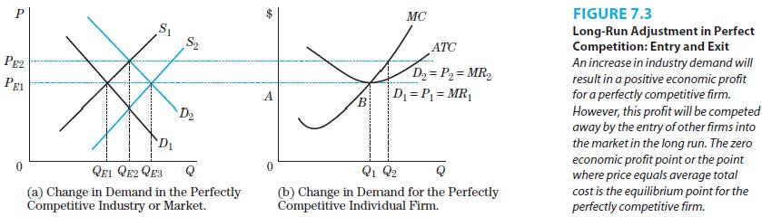

* 1. Adjustment in the Potato Industry
     1. The long-run adjustment process applies to the potato industry.

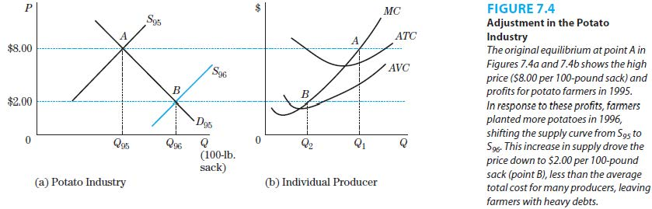

* + 1. The high price of $8 per 100-pound sack and profits earned by individual farmers are shown in point A.
    2. In response to the prices and profits, farmers planted more potatoes in 1996. The favorable weather and insect conditions helped increase the supply and driving down the price to $2 per 100-pound sack.
    3. The new price was below the average total cost for many farmers, leaving them with significant debt.
  1. **Long-Run Adjustment in Perfect Competition: The Optimal Scale of Production**

1. Entry and exit in a perfectly competitive industry result in the zero-profit equilibrium (P=ATC).
2. Positive profits signal new firms to enter while negative profits signal firms to exit the industry.
3. The long-run average cost curve (LRAC) incorporates both economies of scale and diseconomies of scale for the firm.

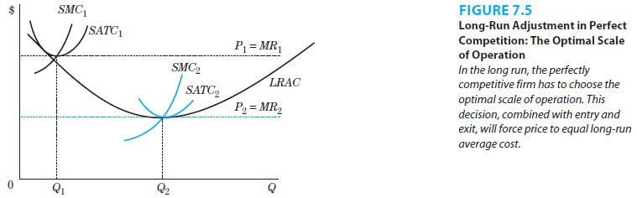

* + - 1. Economies of Scale: Achieving lower unit costs of production by adopting a larger scale of production, represented by the downward sloping portion of a LRAC.
      2. Diseconomies of Scale: Incurring higher unit costs of production by adopting a larger scale of production, represented by the upward sloping portion of a LRAC.

1. The two types of adjustments that are made to reach equilibrium (P=LRAC) in the long run are:
2. the choice of the scale of operation, and
3. entry by firms that lowers product price and competes away any positive economic profits.

|  |
| --- |
| **References** |

Mankiw, N. Gregory. *Principles of economics*. Cengage Learning, 2018.

Farnham, P.G. 2013. *Economics for Managers*. 3rd edn. United States of America: Prentice Hall.