|  |
| --- |
| **Topic 3: Elasticities** |

* 1. **Demand Elasticity**

Demand Elasticity: Quantitative measurement showing the percentage change in the quantity demanded of a particular product relative to the percentage change in any one of the variables included in the demand function for that product. Elasticity measures the responsiveness of consumers in terms of percentage changes in both variables.

Price Elasticity of Demand (eP): Percentage change in the quantity demanded of a given good, X, relative to a percentage change in its price, all other factors constant.

1. Equation 3.1: eP= %∆QX / %∆PX

where:

eP= price elasticity of demand

∆= the absolute change in the variable: (Q2-Q1) or (P2-P1)

1. Price elasticity of demand is illustrated by the change in quantity demanded from Q1 to Q2 as the price changes from P1 to P2.
2. This is shown as the movement along the demand curve from A to B in Figure 3.1.

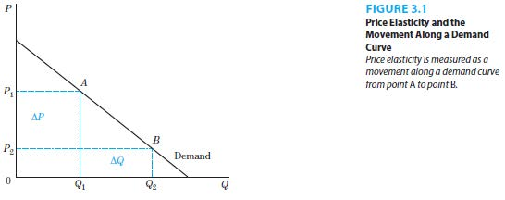

1. The price elasticity of demand affects managerial decisions on pricing strategies through the total revenue.
2. Total Revenue: The amount of money received by a producer for the sale of its product calculated as the price per unit times the quantity sold.
3. Price elasticities for downward sloping demand curves are negative because of the inverse relationship between price and quantity demanded. However, to determine the size of the price elasticity, absolute values are taken for the coefficients.
4. Unitary Elasticity: |eP|=1, when the magnitude of the percentage change in quantity demanded is equal to the magnitude of the percentage change in price.
5. Elastic Demand: |eP|>1, when the magnitude of the percentage change in quantity demanded is greater than the magnitude of the percentage change in price.
6. Inelastic Demand: |eP|<1, when the magnitude of the percentage change in quantity demanded is less than the magnitude of the percentage change in price.
7. Price elasticity of demand and total revenue are related in the following ways.
8. When demand is elastic, a higher price will decrease total revenue while a lower price will increase total revenue. This is illustrated in Figure 3.2.

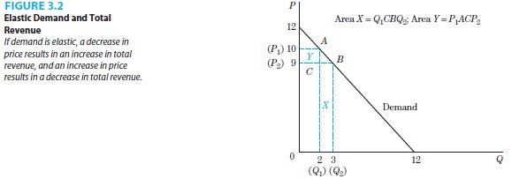

1. When demand is inelastic, a higher price will increase total revue while a lower price will decrease total revenue. This is illustrated in Figure 3.3.

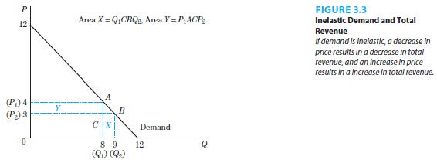

1. When demand is unit elastic, there is no change in the total revenue.
2. Managerial rule of thumb: elasticity can be estimated as Px/(P1-P2). We can either use the average price (midpoint formula) or the starting value for Px. The textbook uses the starting value of P1.
3. The rule is derived from the elasticity equation 3.2 on page 49. Since we assume that the quantity demanded changes from Q1 to zero, the change in quantity demanded equals Q1, thereby simplifying the equation 3.2 to the managerial rule stated above.
   1. **Determinants of Price Elasticity of Demand**
4. Number of Substitute Goods
5. Demand is more inelastic when there are fewer substitutes available, all else constant.
6. An example of inelastic demand is airline travel by business passengers due to the lack of available substitute modes of transportation.
7. Percent of Consumer’s Income Spent on the Product
8. Demand is more inelastic when a smaller fraction of a consumer’s income is spent on the product, all else constant.
9. An example of inelastic demand is the local newspaper since it makes up a very tiny fraction of a consumer’s income.
10. Time Period
11. Demand is more inelastic when the time period under consideration is short, all else constant.
12. It takes time for substitute products to be made available.
    1. **Numerical Example of Elasticity, Prices and Revenues**
13. Calculating Price Elasticities
14. Arc Price Elasticity of Demand: A measurement of the price elasticity of demand where the base quantity or price is calculated as the average value of the starting and ending quantities or prices.
15. If Q1 and Q2 are very different from each other, a different value for the percentage change in quantity demanded may result.
16. If P1 and P2 are very different from each other, a different value for the percentage change in price may result.
17. To remedy these problems, the following equation is used.
18. Equation 3.3: eP= (Q2-Q1)/ [(Q1+Q2)/2]

(P2-P1)/ [(P1+P2)/2]

1. Point Price Elasticity of Demand: A measurement of the price elasticity of demand calculated as a point on the demand curve using infinitesimal changes in prices and quantities.
2. For a specific demand function, appropriate derivatives can be computed.
3. Equation 3.4: eP= dQX PX

dPx QX

1. Price elasticity is not the same as the slope. Even though the demand curve is linear and has a single slope, the price elasticity coefficients vary.
2. The price elasticity coefficient is larger (smaller) at higher (lower) prices for a linear demand function.
3. In the elastic (inelastic) portion of the linear demand curve, a decrease (increase) in price results in an increase (decrease) in total revenue.
4. In the elastic (inelastic) portion of the linear demand curve, marginal revenue is positive (negative) and decreasing in value.
5. Demand Elasticity, Marginal Revenue, and Total Revenue
6. Figure 3.4 illustrates the relationship between demand and marginal revenue.

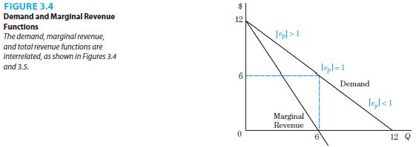

Figure 3.4 and Table 3.5 connect elasticity to total revenue and marginal revenue.

* 1. **Vertical and Horizontal Demand Curves**

1. Two polar cases of demand curves, vertical and horizontal demand curves are important.
2. Perfectly Inelastic Demand: Zero elasticity of demand, illustrated by a vertical demand curve, where there is no change in quantity demanded for any change in price.
3. An example is the demand for insulin by a diabetic, who is completely unresponsive to changes in price.

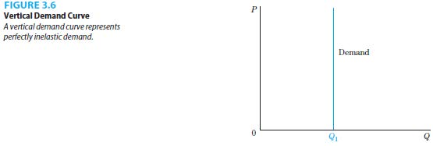

1. Perfectly Elastic Demand: Infinite elasticity of demand, illustrated by a horizontal demand curve, where there the quantity demanded would vary tremendously if there were any changes in price.
2. There is no exact application of a perfectly elastic demand in reality. Examples that illustrate this idea are the demand for common fruits and vegetables.

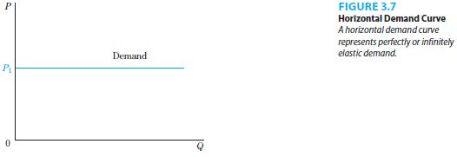

* 1. **Income and Cross-Price Elasticity of Demand**

1. Income Elasticity of Demand: The percentage change in the quantity demanded of a given good, X, relative to a percentage change in consumer income, all other factors constant.
2. Normal Good: A product whose demand will increase with an increase in income. This good has a positive income elasticity of demand.
3. Inferior Good: A product whose demand will decrease with an increase in income. This good has a negative income elasticity of demand.
4. For goods with positive income elasticities, a distinction between necessities and luxuries is made.
5. Necessity: A good with income elasticity between 0 and 1 where the expenditure on the good increases less proportionately with changes in income.
6. Luxury: A good with an income elasticity great than 1 where the expenditure on the good increases more proportionately with changes in income.
7. Cross-Price Elasticity of Demand: The percentage change in the quantity demanded of a given good, X, relative to the percentage change in the price of good Y, all other factors constant.
8. Substitute Goods: Products that can be used in place of one another. These goods have a positive cross-price elasticity of demand.
9. Complementary Goods: Products that are used together. These goods have a negative cross-price elasticity of demand.

|  |
| --- |
| **References** |

Mankiw, N. Gregory. *Principles of economics*. Cengage Learning, 2018.

Farnham, P.G. 2013. *Economics for Managers*. 3rd edn. United States of America: Prentice Hall.