|  |
| --- |
| **Topic 1: Introduction to Economics** |

* 1. **The Scope of Economics**

1. Microeconomics: Branch of economics that analyses the decisions of individual consumers, firms and industries. Microeconomics is analogous to viewing a detailed picture of the economy under the microscope.
2. Prices, amounts of money charged for goods and services in the economy, influence the behavior of consumers and producers.
3. Prices of outputs and inputs (land, labor capital, raw materials, entrepreneurship) affect production decisions of firms.
4. Macroeconomics: Macroeconomics is the branch of economics that focuses on the overall level of economic activity, changes in the price level, and the amount of unemployment by analyzing group or aggregate behavior in different sectors of the economy.
   1. **Economics Defined**

**Scarcity**

* Economic questions arise because we always want more than we can get, so we face **scarcity**, the inability to satisfy all our wants. Everyone faces scarcity because no one can satisfy *all* of his or her wants.

What, How, and For Whom?

* **Goods and services** are the objects that people value and produce to satisfy human wants.
* Societies must answer three very basic questions:
* *What*?: What determines the quantities of the goods and services produced?
* *How?*: How are goods and services produced?
* *For Whom?*: For whom are goods and services produced?

When Is the Pursuit of Self-Interest in the Social Interest?

* People make choices they are think are best for them, that is, choices in their **self-interest.**
* Choices that are the best for society as a whole are said to be in the **social interest**.
* A major question economists explore is “Could it be possible that when each of us makes choices in our self-interest, these choices are in the social interest?’
  1. **The Economic Way of Thinking**

Core Economic Ideas

* Five core ideas describe the economic way of thinking about the choices that must be made:
* People make *rational choices* by comparing costs and benefits.
* Cost is what *must be given up* to get something.
* *Benefit* is what is gained when you get something and is measured by what is *willing to be given up* to get it.
* A rational choice is made on the *margin*.
* Choices respond to *incentives*.

Rational Choice

* A **rational choice** is one that uses the available resources to most effectively satisfy the wants of the person making the choice. Rational choices compare costs and benefits and are made on the margin. They respond to incentives.

Cost: What You *Must* Give Up

* The **opportunity cost** of an activity is the highest-valued alternative that we give up to get something.
* Choices have an opportunity costs; for example, the opportunity costs of attending college include goods and services forgone from paying for tuition and textbooks, and the goods and services forgone because the student does not have the income from a full-time job.

Benefit: Gain Measured By What You Are *Willing* to Give Up

* The **benefit** of something is the gain or pleasure it brings. Economists measure the benefit of something by what a person is willing to give up to get it.

On the Margin

* Making choices at the **margin** means comparing all the relevant alternatives systematically and incrementally.
* People make choices at the margin by comparing the benefit from a one-unit change in an activity (which is the **marginal benefit**) to the cost of making a one-unit change in an activity (which is the **marginal cost**).
* If the marginal benefit of an action exceeds the marginal cost of the action, then the **rational** choice is to take the action.

Responding to Incentives

* An **incentive** is a reward that encourages a choice or a penalty that discourages a choice.
* Changes in marginal benefits and marginal costs alter the incentives that we face when making choices. When incentives change, people’s decisions change. For example, if homework assignments are weighed more heavily in a class’s final grade, the marginal benefit of completing homework assignments has increased and more students will do the homework.
  1. **The Economic Problems**

Economics units are subjected to several constrains due to scarcity (limited resources). A common constraint is the budget constraint. Hence every economic unit needs to make choices based on their preference (priority). As rational economic decision-making units, they will prefer a choice that gives them the highest utility. The next best alternative is the opportunity cost to them. For utility determination, we can refer to the indifference curve, while opportunity cost can be analysed using the production possibility frontier (PPF).

**Production Possibilities and Opportunity Cost**

**The *production possibility frontier (PPF)*** is a graph that shows all of the combinations of goods and services that can be produced if all of society’s resources are used efficiently.

* + To illustrate the *PPF*, we focus on two goods at a time and hold the quantities of all other goods and services constant.
  + *That is, we look at a model economy in which everything remains the same (ceteris paribus) except the two goods we’re considering.*

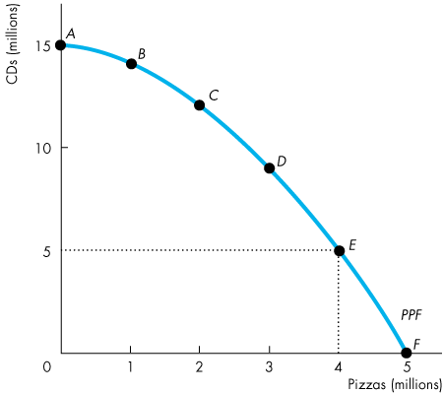

* + The figure shows the *PPF* for CDs and pizza, which stand for any pair of goods and services.

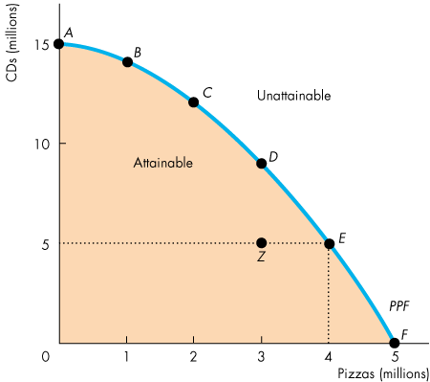

* + Points inside and on the frontier, such as points *A*, *B*, *C*, *D*, *E*, *F*, and *Z* are attainable.
  + Points outside the frontier are unattainable.
  + Points on the frontier are efficient.

**Opportunity Cost**

* The *PPF* makes the concept of opportunity cost precise. If we move along the *PPF* from *C* to *D* the opportunity cost of the increase in pizza.

**Using Resources Efficiently**

* Efficient Use of Resources
  + When we cannot produce more of any one good without giving up some other good, we have achieved *production efficiency*, and we are producing at a point on the *PPF*.

|  |
| --- |
| **References** |

Mankiw, N. Gregory. *Principles of economics*. Cengage Learning, 2018.

Farnham, P.G. 2013. *Economics for Managers*. 3rd edn. United States of America: Prentice Hall.