|  |
| --- |
| **Topic 3: Supply and Equilibrium Prices** |

* 1. **Supply**

1. Supply: Functional relationship between the price and quantity supplied of goods and services by producers in a given period of time, all else equal.
2. Non-price factors influence the cost of production, causing either an increase or a decrease in supply. These factors are the following.
3. State of Technology
   * + 1. Better technology allows for a more efficient use of resources, increasing supply.
4. Input Prices
5. Lower prices of inputs (labor, capital, land and raw materials) lead to a reduction in the production cost and an increase in supply.
6. Prices of Goods Related in Production
7. Substitute Goods: The same inputs can be used to produce one good over another. An increase in the price of a substitute good, Y, causes an increase in the production of good X.
8. Complementary Goods: Products that are produced together. A decrease in the price of a complementary good, Y, causes an increase in the production of good X.
9. Future Expectations
10. An expected decrease in the future price of good X will increase its current supply.
11. Number of Producers
12. An increase in the number of sellers of good X will increase its supply.
    * + 1. Changes in laws or regulations including trade barriers (quotas and tariffs) can also achieve the same result.
13. Supply Curve: The graphical relationship between the price of a good (P) and the quantity supplied by producers (Q), with all other factors influencing supply held constant.

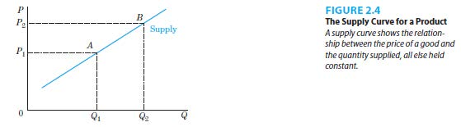

1. Supply Shifters: The variables in a supply function that are held constant when defining a given supply curve. If their values change, the supply curve would shift.
2. Price is on the vertical axis and quantity supplied is on the horizontal axis.
3. Supply curves are generally upward sloping.
4. Price and quantity supplied have a positive relationship.
5. Change in Quantity Supplied and Change in Supply
6. Change in Quantity Supplied: Movement along a supply curve when producers react to a change in the price of the product, all other factors held constant. This is illustrated in Figure 2.4.



1. Change in Supply: Movement of the entire supply curve when producers react to a change in factors other than the price of the product changing. This is illustrated in Figure 2.5. Factors capable of shifting a supply curve (changes in supply) include technological changes that increase input productivity, changes in input costs, changes in the prices of related in production goods, changes in producer’s expectations.

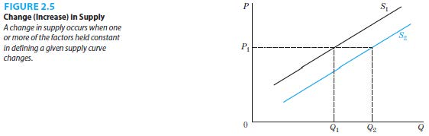

1. Summary of Demand and Supply Factors
2. Table 2.1 provides a summary of the discussion

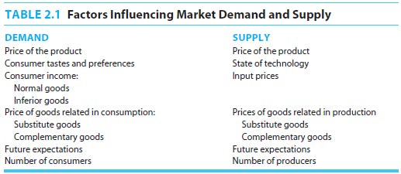

* 1. **Demand, Supply and Equilibrium**

1. When the market is in equilibrium, there is an equilibrium price and quantity. This is illustrated in Figure 2.6.

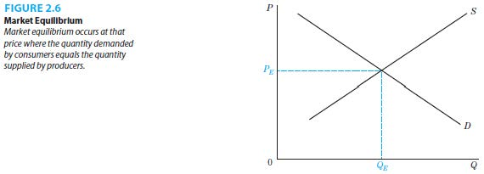

* + 1. Equilibrium Price (PE): The price that actually exists in the market (or toward which the market is moving) where the quantity demanded by consumers equals the quantity supplied by producers.
    2. Equilibrium Quantity (QE): The quantity of a good, determined by the equilibrium price, where the amount of output that consumers demand is equal to the amount that producers want to supply.

1. Lower-than-equilibrium prices would result in a shortage of the good, as the quantity demanded exceeds the quantity supplied. This is illustrated in Figure 2.7.

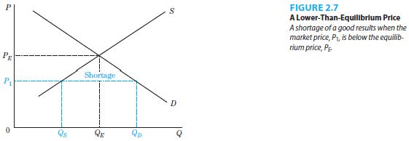

1. Higher-than-equilibrium prices would result in a surplus of the good, as the quantity supplied exceeds the quantity demanded. This is illustrated in Figure 2.8.

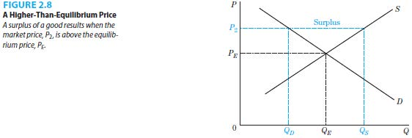

1. Changes in Equilibrium Prices and Quantities
2. A change in demand results from a change in tastes and preferences, income, prices of related goods, expectations or the number of consumers. This alters the market equilibrium in the following ways.

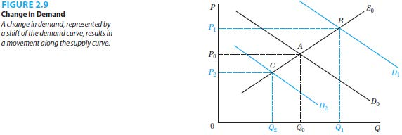

* + - 1. An increase in demand (D0 to D1) raises the equilibrium price and raises the equilibrium quantity. This is illustrated in Figure 2.9.
      2. A decrease in demand (D0 to D2) lowers the equilibrium price and lowers the equilibrium quantity. This is illustrated in Figure 2.9.

1. A change in supply results from a change in technology, input prices, prices of goods related in production, expectations, or the number of suppliers. This alters the market equilibrium in the following ways.

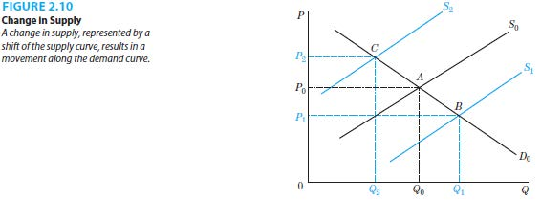

1. An increase in supply (S0 to S1) lowers the equilibrium price and raises the equilibrium quantity. This is illustrated in Figure 2.10.
2. A decrease in supply (S0 to S2) raises the equilibrium price and lowers the equilibrium quantity. This is illustrated in Figure 2.10.
3. The effects of changes in both sides of the market on the equilibrium price and quantity depend on the sizes of the shifts of the demand and supply curves.
4. An increase in demand and a decrease in supply raise the equilibrium price but the effect on the equilibrium quantity is indeterminate. This is illustrated in Figures 2.11 and 2.12.

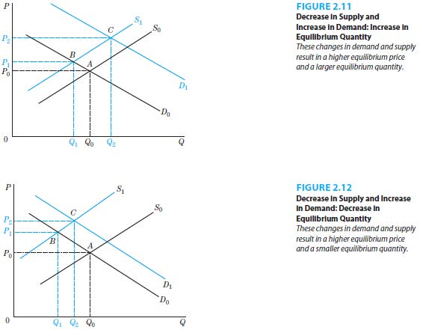

1. An increase in demand and an increase in supply raise the equilibrium quantity but the effect on the equilibrium price is indeterminate. This is illustrated in Figures 2.13 and 2.14.

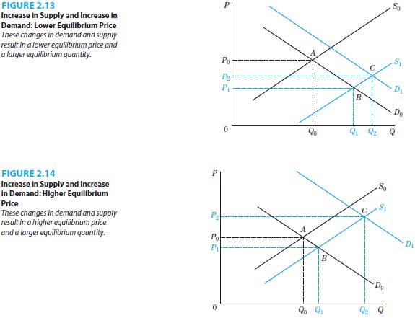

|  |
| --- |
| **References** |

Mankiw, N. Gregory. *Principles of economics*. Cengage Learning, 2018.

Farnham, P.G. 2013. *Economics for Managers*. 3rd edn. United States of America: Prentice Hall.