|  |
| --- |
| **Topic 7: Market Structure: Oligopoly** |

* 1. **Oligopoly**

Oligopoly firms typically have market power derived from barriers to entry. The key characteristic is that there are a small number of firms competing with each other so their behavior is mutually interdependent. The interdependence means that the strategies and decisions by managers of one firm affect managers of other firms, whose subsequent decisions then affect the first firm.

* 1. Oligopoly: A market structure characterized by competition among a small number of large firms that have market power, but that must take their rivals’ actions into account when developing their own competitive strategies.
  2. The airline industry has numerous examples of interdependent behavior.

* + 1. Frontier’s aggressive pricing and scheduling, especially at Denver, increased its market share relative to its rival and dominant airline, United.
    2. Provision of luxury amenities on international flights until the recent economic downturn.

1. Oligopoly Models
   1. Economists have developed a variety of models to capture different aspects of the interdependent behavior inherent in oligopoly.
   2. The models can be divided into two basic groups, noncooperative and cooperative models.
      1. Noncooperative Oligopoly Models: Models of interdependent oligopoly behavior that assume that firms purse profit-maximizing strategies based on assumptions about rivals’ behavior and the impact of this behavior on the given firm’s strategies.
      2. Cooperative Oligopoly Models: Models of interdependent oligopoly behavior that assumes that firms explicitly or implicitly cooperate with each other to achieve outcomes that benefit all the firms.
   3. **Noncooperative Oligopoly Models**
2. The Kinked Demand Curve Model
3. Kinked Demand Curve Model: An oligopoly model based on two demand curves that assumes that other firms will not match a firm’s price increases but will match its price decreases.
4. This model assumes that a firm is faced with two demand curves forming a kink at the current price level.

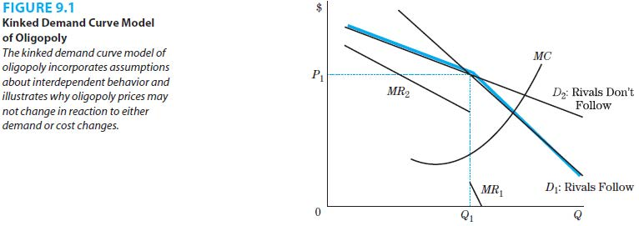

1. D1 reflects demand for its product if all rival firms follow the given firm’s prices changes. D2 reflects demand if other firms do not follow the given firm’s price changes.
2. D1 is relatively more inelastic than D2 since D1 shows the effect on the firm’s quantity demanded if all firms follow its price change.
3. Game Theory Models
4. Game theory models apply game theory to oligopoly behavior.
   * + 1. Game Theory: A set of mathematical tools for analyzing situations in which players make various strategic moves and have different outcomes or payoffs associated with those moves.
5. The outcomes including prices, quantities and profits are a function of the strategic behavior adopted by the interdependent rival firms.
6. The most well-known game theory example is the Prisoner’s Dilemma. In this game, all players have a dominant strategy.
7. Dominant Strategy: A strategy that results in the best outcome or highest payoff to a given player no matter what action or choice the other player makes.
8. However, a dilemma occurs when all players choose their dominant strategies and end up worse off than if they had been able to coordinate their choice of strategy.
9. Many games will not have dominant strategies in which players choose a strategy that is best for them regardless of what their rival chooses to do. In these situations, players choose the best strategy, given the actions of the other players.
10. Nash Equilibrium: A set of strategies from which all players are choosing their best strategy, given the actions of the other players.
11. The prisoner’s dilemma is an example of simultaneous decision making.
12. Strategies and outcomes differ if decisions are made sequentially.
13. Strategic Entry Deterrence
14. Oligopoly firms also try to limit competition from rivals by practicing strategic entry deterrence. One such policy is limit pricing.
15. Strategic Entry Deterrence: Strategic policies pursued by a firm that prevent other firms from entering the market.
16. Limit Pricing: A policy of charging a price lower than the profit-maximizing price to keep other firms from entering the market, as illustrated in Figure 9.2.

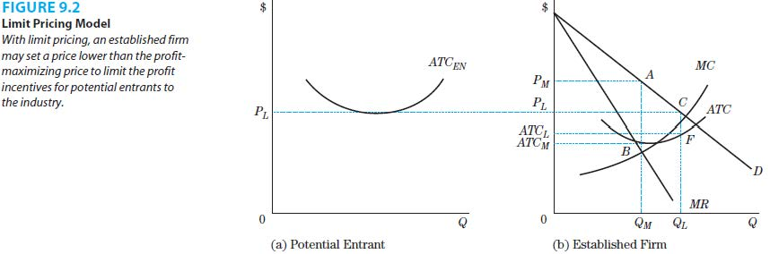

1. To thwart entry, the established firm can charge the limit price, PL (a price that is lower than the profit-maximizing price), rather than the profit-maximizing price PM.
2. Limiting pricing strategies must be credible and rivals must be convinced that the established firm will continue its policy of low prices.
3. Xerox is an example of an oligopoly firm that engaged in strategic entry deterrence.
4. Predatory Pricing
5. Predatory pricing is another strategy that oligopoly firms use.
6. Predatory Pricing: A strategy of lowering prices below cost to drive firms out of the industry and scare off potential entrants.
7. The firm practicing predatory pricing must lower its price below cost and incur losses itself with the expectation that the losses will be offset by future profits.
8. The predatory firm also has to convince other firms that it will leave the price below cost until other firms leave the market.

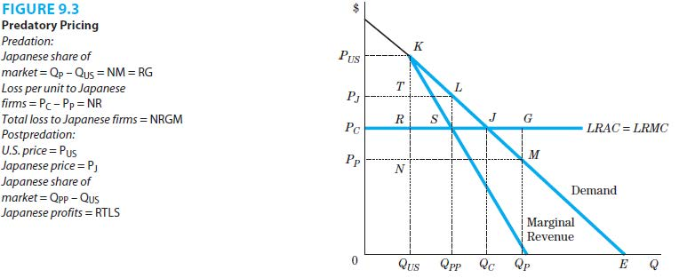

1. The textbook presents two illustration of predatory pricing. The first is of Matsushita and six other Japanese electronics firms were accused by National Union Electro Corporation and Zenith Radio Corporation of charging different prices in Japan and the US, with the prices in the US market being below the costs of production. are examples of oligopoly firms that engaged in predatory pricing. The second is Spring Airlines versus Northwest Airlines.
   1. **Cooperative Oligopoly Models**
2. A second set of oligopoly models focuses on cooperative behavior among rivals.
3. Cartels
4. Cartel: An organization of firms that agree to coordinate their behavior regarding pricing and output decisions to maximize profits for the organization.
5. Cartels engage in joint profit maximization.
6. Joint Profit Maximization: A strategy that maximizes profits for a cartel but may create incentives for individual members to cheat.
7. The potential to cheat exists because what is optimal for the cartel as a whole may not be optimal for individual cartel members.

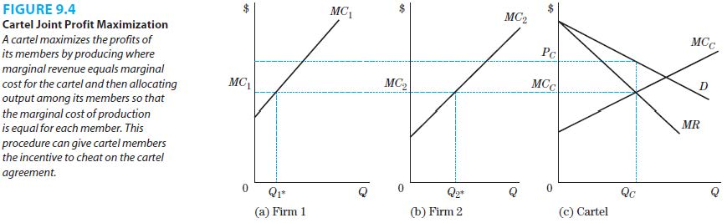

1. The marginal cost for the cartel, MCC, is derived through the horizontal summation of marginal cost curves of the individual firms, as is illustrated in Figure 9.4 above.
2. Horizontal summation of the marginal cost curves: For every level of marginal cost, add the amount of output produced by each firm to determine the overall level of output produced at each level of marginal cost.
3. For joint profit maximization, the cartel must determine the overall level of output to produce, the price to charge, and how to allocate the output among cartel members.
4. The allocation rule for joint profit maximization is to produce where each firm’s marginal cost is equal to the cartel’s marginal cost.
5. Cartel members have an incentive to cheat on the cartel agreement. The reason for this incentive is the restriction of the output that causes the marginal cost of each firm to be less than the cartel price. Recall that profit maximization requires that MC equals MR, and in the case of a carter, each firm sees the cartel price as its MR. Of course, this starts to change as cheating expands and causes the price to decrease.
6. A cartel is most likely to be successful when:
7. It can raise the market price without inducing significant competition from non-cartel members;
8. The expected punishment from forming the cartel is low relative to the expected gains;
9. The costs of establishing and enforcing the agreement are low relative to the gains.
10. In the United States, price and output-fixing arrangements of cartels are illegal under the Sherman Antitrust Act of 1890.
11. OPEC, the Organization of Petroleum Exporting Countries, is the most well-known cartel. Saudi Arabia is the dominant player given its vast oil reserves.
12. In recent years, competition from non-cartel members has severely limited the strength of OPEC.
13. The cartel further reduced its strength when member countries could not come to an agreement on the production quota and the target price for a barrel of oil.
14. Tacit Collusion
15. Since cartels are illegal in the United States, firms may engage in tacit collusion.
16. Tacit Collusion: Coordinated behavior among oligopoly firms that is achieved without a formal agreement.
17. Tacit collusion is facilitated by practices such as:
18. Uniform prices;
19. A penalty for price discounts;
20. Advance notice of price changes;
21. Information exchanges; and
22. Swaps and exchanges.
23. In some cases, there is formal price leadership.
24. Price Leadership: An oligopoly strategy in which one firm in the industry institutes price increases and waits to see if they are followed by rival firms.
25. Collusive behavior is also strengthened by information exchange such as identifying new customers and the prices and terms offered to them.
26. Examples of tacit collusive behavior are the Ethyl case and the airline tariff publishing case.

|  |
| --- |
| **References** |

Mankiw, N. Gregory. *Principles of economics*. Cengage Learning, 2018.

Farnham, P.G. 2013. *Economics for Managers*. 3rd edn. United States of America: Prentice Hall.