|  |
| --- |
| **Topic 6: Market Structure: Monopoly** |

* 1. **Monopoly**

The market structures of monopoly and monopolistic competition, along with oligopoly, are called imperfectly competitive markets.Managers of firms in these markets have varying degrees of market power, or the ability to influence prices and develop other competitive strategies.The degree of market power is related to the barriers to entry (structural, legal or regulatory) in a given market.

1. Firms with Market Power
   1. Market Power: The ability of a firm to influence the prices of its product and develop other competitive strategies that enable it to earn large profits over longer periods of time.
   2. The Monopoly Model
      1. Monopoly: A market structure characterized by a single firm producing a product with no close substitutes.
      2. Any firm in imperfect competition faces a downward sloping demand curve, as it is not a price-taker, but a price-setter.
         1. Price Setter: A firm in imperfect competition that faces a downward sloping demand curve and must set the profit-maximizing price to charge for its product.
      3. To sell more output, an imperfectly competitive firm must lower the price of the product.
      4. The marginal revenue curve is downward slopped and separate from the demand curve.

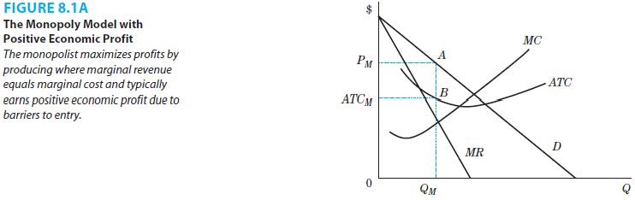

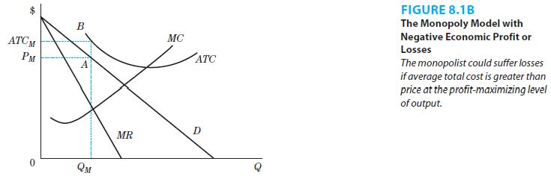

* + 1. The profit-maximizing level of output, QM, is still where the marginal revenue equals marginal cost. However, the price, PM, that a monopolist can charge is read directly off the demand curve. As a result, there is so supply curve in this model. The monopoly determines the profit-maximizing level of output by equating MC and MR, but the price is determined by the demand (the highest price at which the output can be absorbed by the demand).
    2. A monopolist can earn positive, zero or negative profits.
    3. However, unlike perfect competition, positive economic profits cannot be competed away through the entry of other firms due to barriers to entry.
    4. The monopoly price, PM, is greater than the marginal cost of production.
  1. Comparing Monopoly and Perfect Competition
     1. The goal of all firms is profit maximization. Regardless of market structure, the profit maximizing level of output occurs where marginal revenue equals marginal cost.

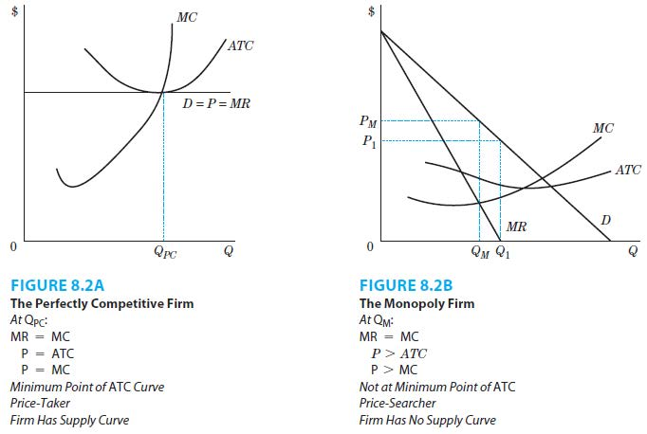

* + 1. The perfectly competitive firm faces a horizontal demand curve because it takes the price set by the forces of demand and supply in the market as given.
    2. The above combined with the goal of profit maximization means that the firm produces at the level of output where price equals marginal cost.
    3. The perfectly competitive firm’s supply curve is the rising portion of the marginal cost curve that lies above the minimum average variable cost.
    4. In equilibrium, perfectly competitive firms produce where price equals average total cost and earn zero economic profit. Any positive or negative profits will be competed away through the entry and exit of firms.
    5. The monopolist produces where marginal revenue equals marginal cost but it searches out the optimal price.
    6. The firm with market power will produce a level of output where price is greater than the marginal cost.
    7. For the firm with market power, both the marginal revenue and demand curves are downward sloping and are separate curves.
    8. Firms with market power typically earn positive profits. The amount and length of time they can earn these profits depend on barriers to entry.

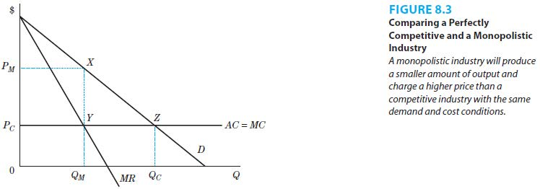

* + 1. Under monopoly, price will be higher and the output will be lower than under perfect competition with the same demand and cost conditions.
    2. There is a misallocation of resources in monopoly compared with perfect competition.
  1. Sources of Market Power: Barriers to Entry
     1. Barriers to entry help firms maintain market power and earn positive economic profits.
        1. Barriers to Entry: The structural, legal, or regulatory characteristics of a firm and its market that keep other firms from producing the same or similar products at the same cost.
     2. The following are barriers to entry.
        1. Economies of scale and mergers;
        2. Barriers created by the government;
        3. Input barriers;
        4. Brand loyalties;
        5. Consumer lock-in and switching costs; and
        6. Network externalities.
     3. Economies of scale acts as a barrier to entry since only large-scale firms can achieve the cost-reduction benefits of these economies.
     4. Mergers are one means of achieving necessary size to realize economies of scale. These are important in industries where fixed costs are large and marginal costs are very low.
        1. The minimum efficient scale (MES) production in the beer industry contributed to the large number of mergers.
        2. The commodities boom contributed to mergers in the mining industry.
     5. Barriers to entry created by the government include licenses, patents and copyrights.
     6. Licensing of physicians and other professionals is the basis for maintaining the quality of the individuals in these professions.
        1. Licensing in the medical industry may not remain the same as more states allow psychologists to prescribe medication.
     7. Patents and copyrights give the producer of a new invention or printed work the right to the profits from that work for a number of years to encourage research.
        1. The duration of patent protection is important since generic drug makers can enter the market if patents have expired or the copies do not infringe on the patents.
     8. Other barriers include control over raw materials or key inputs in a production process.
     9. The creation of brand loyalties through advertising and other marketing efforts is a strategy that managers use to create and maintain market power.

|  |
| --- |
| **References** |

Mankiw, N. Gregory. *Principles of economics*. Cengage Learning, 2018.

Farnham, P.G. 2013. *Economics for Managers*. 3rd edn. United States of America: Prentice Hall.