|  |
| --- |
| **Topic 2: Demand, Supply, and Equilibrium Prices** |

* 1. **Demand**

1. Demand: Functional relationship between the price and quantity demanded of goods and services by consumers in a given period of time, all else held constant.
2. Non-price factors influence demand, causing either an increase or a decrease in demand. These factors are the following.
3. Tastes and Preferences
4. A favorable change in the taste for good X increases its demand.
5. Income
6. Normal Good: A product whose demand will increase with an increase in income.
7. Inferior Good: A product whose demand will decrease with an increase in income.
8. Prices of Related Goods
9. Substitute Goods: Products that can be used in place of one another. An increase in the price of a substitute good, Y, causes an increase in the demand for good X.
10. Complementary Goods: Products that are used together. A decrease in the price of a complementary good, Y, causes an increase in the demand for good X.
    * 1. Future Expectations
         1. An expected increase in the future price of good X will increase its current demand.
         2. This was demonstrated in the world grain prices in 2007 and in steel prices in 2011.
      2. Number of Consumers
    1. Demand Function: Function represented by QXD= f (PX, T, I, PY, PZ, EXC, NC, ...) where:

QXD= quantity demanded of X

PX= price of X

T= variables representing an individual’s tastes and preferences

I= income

PY, PZ= prices of goods Y and Z, which are related in consumption to good X

EXC= consumer expectations about future prices

NC= number of consumers

* + 1. Individual Demand Function: Function that shows the variables that affect an individual consumer’s quantity demanded of a particular product.
    2. Market Demand Function: Function that shows the variables that affect all consumers’ quantity demanded of a particular product in the market.
  1. Demand Curve: The graphical relationship between the price of a good (P) and the quantity demanded by consumers (Q), with all other factors influencing demand held constant.

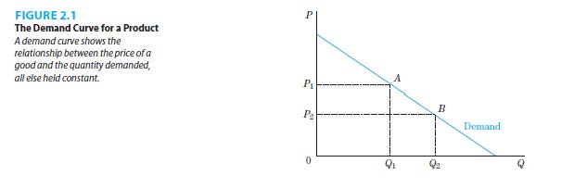

* + 1. Demand Shifters: The variables in a demand function that are held constant when defining a given demand curve. If their values change, the demand curve would shift.
    2. Price is on the vertical axis and quantity demanded is on the horizontal axis.
    3. Demand curves are generally downward sloping.
    4. Price and quantity demanded have a negative relationship.
  1. Change in Quantity Demanded and Change in Demand
     1. Change in Quantity Demanded: Movement along a demand curve when consumers react to a change in the price of the product, all other factors held constant. This is illustrated in Figure 2.1.
     2. Change in Demand: Movement of the entire demand curve when consumers react to a change in factors other than the price of the product changing. This is illustrated in Figure 2.2.

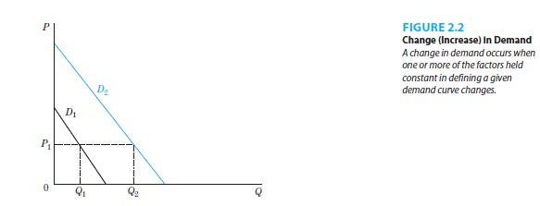

* 1. The market demand curve can be derived by horizontal summation of the individual demand curves.
     1. Horizontal Summation: For every price, add the quantity that each individual in a market demands.
     2. A simple example is when there are two individuals in a market. This is illustrated in Figure 2.3.

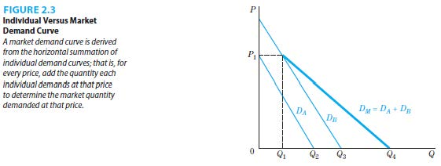

* 1. Linear Demand Function and Curves
     1. Linear Demand Function: Mathematical relationship in which all terms are added or subtracted.
     2. The graph of a linear demand curve is a straight line.
  2. Math Example of a Demand Function (for copper at the beginning of 2010)
     1. Equation 2.2: QD=3-2PC+0.2I+1.6TC+0.4E

where:

QD= quantity demanded of copper (millions of pounds)

PC= price of copper ($ per pound)

I= consumer income index

TC= telecom index showing uses or tastes for copper in the telecommunications industry

E=expectation index representing purchaser’s expectations of a lower price over the following six months

* + 1. The negative coefficient on PC shows an inverse relationship between price and quantity demanded for copper.
    2. The positive coefficient on I shows that copper is a normal good.
    3. The positive coefficient on TC shows that improved technology and greater demand for telecom services lead to higher demand.
    4. The negative coefficient on E shows that expectations of lower price leads to an increased demand for copper in the future but a decreased demand for copper for the current period.
    5. Equation 2.3: QD=15-2PC is the alternative demand equation that is derived after substituting values for I, TC and E. It illustrates the meaning of the expression, “all else equal.”
  1. **Supply**

1. Supply: Functional relationship between the price and quantity supplied of goods and services by producers in a given period of time, all else equal.
2. Non-price factors influence the cost of production, causing either an increase or a decrease in supply. These factors are the following.
3. State of Technology
   * + 1. Better technology allows for a more efficient use of resources, increasing supply.
4. Input Prices
5. Lower prices of inputs (labor, capital, land and raw materials) lead to a reduction in the production cost and an increase in supply.
6. Prices of Goods Related in Production
7. Substitute Goods: The same inputs can be used to produce one good over another. An increase in the price of a substitute good, Y, causes an increase in the production of good X.
8. Complementary Goods: Products that are produced together. A decrease in the price of a complementary good, Y, causes an increase in the production of good X.
9. Future Expectations
10. An expected decrease in the future price of good X will increase its current supply.
11. Number of Producers
12. An increase in the number of sellers of good X will increase its supply.
    * + 1. Changes in laws or regulations including trade barriers (quotas and tariffs) can also achieve the same result.
13. Supply Function: Function represented by QXS= f (PX, TX, PI, PA, PB, EXP, NP, ...) where:

QXS= quantity supplied of X

PX= price of X

TX=state of technology

PI= prices of inputs of production

PA, PB= prices of goods A and B, which are related in production of good X

EXP= producer expectations about future prices

NP= number of producers

1. Supply Curve: The graphical relationship between the price of a good (P) and the quantity supplied by producers (Q), with all other factors influencing supply held constant.

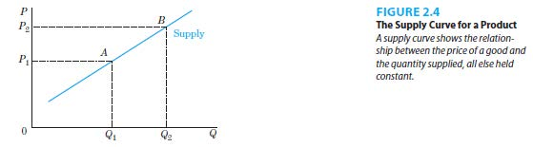

1. Supply Shifters: The variables in a supply function that are held constant when defining a given supply curve. If their values change, the supply curve would shift.
2. Price is on the vertical axis and quantity supplied is on the horizontal axis.
3. Supply curves are generally upward sloping.
4. Price and quantity supplied have a positive relationship.
5. Change in Quantity Supplied and Change in Supply
6. Change in Quantity Supplied: Movement along a supply curve when producers react to a change in the price of the product, all other factors held constant. This is illustrated in Figure 2.4.



1. Change in Supply: Movement of the entire supply curve when producers react to a change in factors other than the price of the product changing. This is illustrated in Figure 2.5. Factors capable of shifting a supply curve (changes in supply) include technological changes that increase input productivity, changes in input costs, changes in the prices of related in production goods, changes in producer’s expectations.

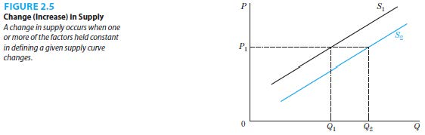

1. Math Example of a Supply Function
2. Equation 2.5: QS= -5+8PC-0.5W+0.4T+0.5N

where:

QS= quantity supplied of copper (millions of pounds)

PC= price of copper ($ per pound)

W= an index of wage rates in the copper industry

T= technology index

N= number of active mines in the copper industry.

1. The positive coefficient on PC shows a positive relationship between price and quantity supplied of copper.
2. The negative coefficient on W shows that as the input price increases, supply decreases due to costly production.
3. The positive coefficient on T shows that an increase in technology increases the supply of copper.
4. The positive coefficient on N shows that an increase in the number of active mines increases the supply of copper.
5. Equation 2.6: QS= -25+8PC is the alternative supply equation that is derived after substituting values for W, T and N. It illustrates the meaning of the expression, “all else equal.”
6. Summary of Demand and Supply Factors
7. Table 2.1 provides a summary of the discussion

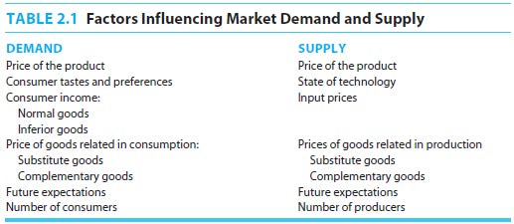

* 1. **Demand, Supply and Equilibrium**

1. When the market is in equilibrium, there is an equilibrium price and quantity. This is illustrated in Figure 2.6.

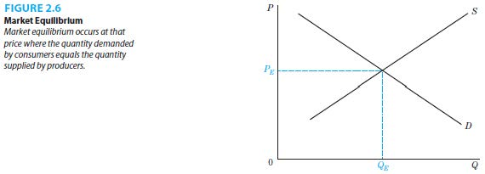

* + 1. Equilibrium Price (PE): The price that actually exists in the market (or toward which the market is moving) where the quantity demanded by consumers equals the quantity supplied by producers.
    2. Equilibrium Quantity (QE): The quantity of a good, determined by the equilibrium price, where the amount of output that consumers demand is equal to the amount that producers want to supply.

1. Lower-than-equilibrium prices would result in a shortage of the good, as the quantity demanded exceeds the quantity supplied. This is illustrated in Figure 2.7.

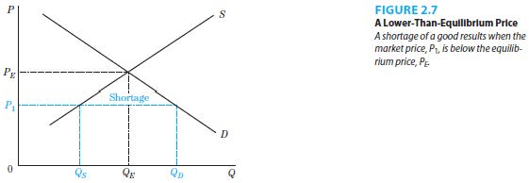

1. Higher-than-equilibrium prices would result in a surplus of the good, as the quantity supplied exceeds the quantity demanded. This is illustrated in Figure 2.8.

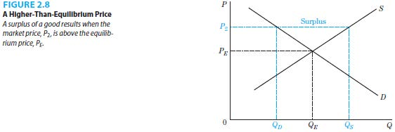

1. Math Example of Equilibrium
2. Equation 2.3: QD= 15-2PC
3. Equation 2.6: QS= -25+8PC
4. In equilibrium, there is only one quantity where QD=QS. Equating the two equations lead to an equilibrium price of $4.00 and an equilibrium quantity of 7 million pounds.
5. Changes in Equilibrium Prices and Quantities
6. A change in demand results from a change in tastes and preferences, income, prices of related goods, expectations or the number of consumers. This alters the market equilibrium in the following ways.

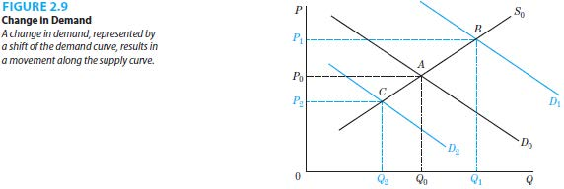

* + - 1. An increase in demand (D0 to D1) raises the equilibrium price and raises the equilibrium quantity. This is illustrated in Figure 2.9.
      2. A decrease in demand (D0 to D2) lowers the equilibrium price and lowers the equilibrium quantity. This is illustrated in Figure 2.9.

1. A change in supply results from a change in technology, input prices, prices of goods related in production, expectations, or the number of suppliers. This alters the market equilibrium in the following ways.

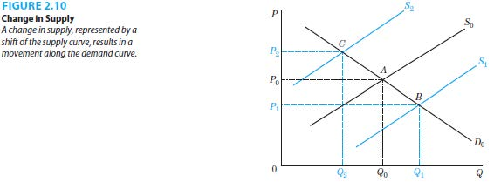

1. An increase in supply (S0 to S1) lowers the equilibrium price and raises the equilibrium quantity. This is illustrated in Figure 2.10.
2. A decrease in supply (S0 to S2) raises the equilibrium price and lowers the equilibrium quantity. This is illustrated in Figure 2.10.
3. The effects of changes in both sides of the market on the equilibrium price and quantity depend on the sizes of the shifts of the demand and supply curves.
4. An increase in demand and a decrease in supply raise the equilibrium price but the effect on the equilibrium quantity is indeterminate. This is illustrated in Figures 2.11 and 2.12.

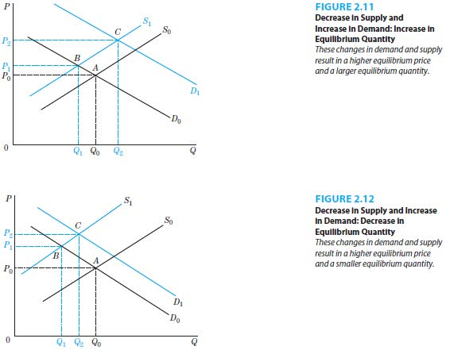

1. An increase in demand and an increase in supply raise the equilibrium quantity but the effect on the equilibrium price is indeterminate. This is illustrated in Figures 2.13 and 2.14.

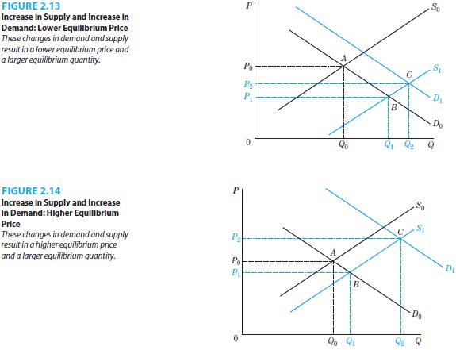

1. Math Example of an Equilibrium Change (continuation of the prior setup of the copper market in 2010
2. Start with an initial equilibrium price of $4.00 and an initial equilibrium quantity of 7 million pounds at the beginning of 2010.
3. Assume that the US and European economic weaknesses cause cancellation of copper orders during 2010 - 2011. Assume that a decrease in the demand for copper that resulted from the weaknesses in the US and Europe was not offset by an increase in the demand for copper from China. This causes several of the relevant to the market demand factors to change: the income index (I) to decrease from 20 to 14, the telecom index (TC) decreases from 2.5 to 1.875, the expectations index (E) decreases from 100 to 80.
4. Supply side factors are also allowed to change. Assume that the wage index (W) decreases from 100 to 98, the technology index increases from 50 to 55, NP increases from 20 to 28 (due to a release of copper stockpile in China).
5. Substituting for new values of for the above listed factors into the demand and supply equations results in the new equilibrium price is $3.00 and the new equilibrium quantity is 6 million pounds. This is also illustrated graphically in Figure 2.15.

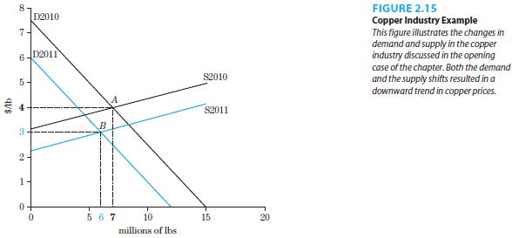

|  |
| --- |
| **References** |

Mankiw, N. Gregory. *Principles of economics*. Cengage Learning, 2018.

Farnham, P.G. 2013. *Economics for Managers*. 3rd edn. United States of America: Prentice Hall.