|  |
| --- |
| **Topic 4: Production and Cost Analysis in The Short Run** |

**4.1 Production**

Production and costs are important for understanding supply. Production functions show how output rises with the inputs used, and the corresponding cost functions show how costs vary with the level of output produced. Production and cost functions are important for analyzing the behavior and strategy of individual firms and industries.

1. Case for Analysis: Production and Cost Analysis in the Fast-Food Industry
   1. Fast-food industry is highly competitive
      1. This implies that firms have little influence over the price of their product
      2. This implies that to increase profits firms need to either lower costs or increase the number of customers
   2. New production technologies such as call centers, internet order taking allow fast food firms to increase the productivity of their labor and thereby reduce the cost of output on per unit basis
      1. McDonald’s has started to utilize internet order taking in Singapore and Turkey.
      2. Use of call centers allows firms to spread the peak hour activity across different time zones thereby increasing the effectiveness of labor.
   3. Production technology changes include the following.
      1. The use of separate kitchens for drive-through windows.
      2. Timers to monitor the time it takes the customers to drive from the menu board to the cash/ pickup window.
      3. Redesigning kitchens to minimize unnecessary movement by the workers.
      4. Use of remote order-taking to cut costs.
2. Defining the Production Function
   1. Production Function: The relationship between a flow of inputs and the resulting flow of outputs in a production process during a given period of time.
      1. The production function shows the maximum amount of output that can be produced with a given combination of inputs.
      2. Equation 5.1: Q=f(L, K, M,…)

where:

Q= quantity of output

L=quantity of labor input

K=quantity of capital input

M=quantity of materials input

* + 1. The production function is a general function and can be applied to large-scale production processes as well as production in small firms.
  1. Fixed Inputs Versus Variable Inputs
     1. Firms use both fixed and variable inputs in a production function.
     2. Fixed Input: An input whose quantity a manager cannot change during a given period of time. Examples are acreage of land and farm equipment for crop production.
     3. Variable Input: An input whose quantity a manger can change during a given period of time. Examples are farm workers, fertilizers, and seeds in crop production.
  2. Short-Run Versus Long-Run Production Functions
     1. Short-Run Production Function: A production process that uses at least one fixed input.
     2. Long-Run Production Function: A production process in which all inputs are variable.
  3. Productivity and the Fast-Food Industry
     1. The *Wall Street Journal* article illustrates the difference between short-run and long-run production.
     2. With fixed inputs and a given technology, employees worked faster to achieve the goal of a 90-second turnaround for each drive-through customer.
     3. In the long-run, as quality decreased and employees became dissatisfied, management responded by placing an intercom at the end of the drive-through line to correct mistakes in orders and rearranged the kitchens.

1. Model of a Short-Run Production Function
   1. Three measures of productivity, or the relationship between inputs and the output, are total product, average product and marginal product.
   2. Total Product: The total quantity of output produced with given quantities of fixed and variable inputs.
      1. Equation 5.2: TP or Q=f(L, )

The bar over K implies that capital stock is fixed.

* 1. Average Product and Marginal Product
     1. Average Product: The amount of output per unit of variable input.
        1. Equation 5.3: AP=TP/L or AP=Q/L

where:

AP= average product of labor

* + 1. Marginal Product: The additional output produced with an additional unit of variable input.
       1. Equation 5.4: MP=∆TP/∆L or MP= ∆Q/∆L

where:

MP= marginal product of labor

* 1. Relationships Among Total, Average and Marginal Product
     1. When the numbers in the total product column increase at in increasing (decreasing) rate, the numbers in the marginal product column increase (decrease). This helps demonstrate increasing (decreasing) marginal productivity as the marginal product represents the rate of change of the total product.
     2. When the marginal product is greater (smaller) than the average product, the average product numbers increase (decrease).
     3. Figures 5.1a and 5.1b illustrate the graphs of these curves and their relationships.

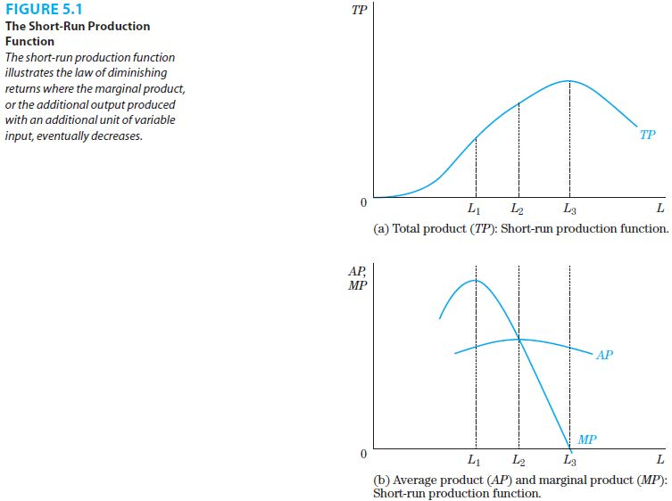

* 1. Economic Explanation of the Short-Run Production Function
     1. Increasing Marginal Returns: The region where the marginal product is positive and increasing so that total product increases at an increasing rate.
     2. Law of Diminishing Marginal Returns or Law of the Diminishing Marginal Product: The region where the marginal product is positive but decreasing so that the total product is increasing at a decreasing rate.
        1. This occurs because capital input and state of technology are held constant in the short-run.
        2. As more labor is added to the fixed capital input, the marginal product eventually starts decreasing.
        3. Examples are too many automobile workers in a factory, too many accountants in an office space, and too many farmers on a plot of land.
     3. Negative Marginal Returns: The region where the marginal product curve is negative so that the total product is decreasing.

1. Real-World Firm and Industry Productivity Issues
   1. Examples of Diminishing Return and Productivity Changes
      1. Poultry farms have traditionally had problems catching chickens inside chicken houses with human catchers.
         1. Machines capable of catching and caging 150 chickens per minute were produced and replaced some of the human catchers.
      2. Retail businesses using either labor-intensive (Amazon.com) or capital intensive (Crate & Barrel) methods of filling out mail orders.
         1. The choice depends on the cost of hiring an additional worker versus an additional unit of capital.
      3. Hospitals are increasingly treating larger numbers of patients with fixed numbers of hospital beds and buildings.
         1. Identical rooms are designed so that doctors and nurses can find equipment easily.
         2. Nurse stations are placed so that all patients are visible.
         3. Filers and ultraviolet devices kill germs and reduce infections.

* + 1. Reorganization of the workplace in luxury handbag industry.

**4.2 Model of Short-Run Cost Functions**

1. Cost Functions: A mathematical or graphical expression that shows the relationship between the cost of production and the level of output, all other factors held constant.
2. Economists define costs as opportunity costs.
3. Opportunity Cost: The economic measure of cost that reflects the use of resources in one activity, such as a production process by one firm, in terms of the opportunities foregone in undertaking the next best alternative activity.
   * + 1. Opportunity costs include implicit as well as explicit costs.
       2. Explicit Costs: A cost that is reflected in a payment to another individual, such as a wage paid to a worker, that is recorded in a t
       3. Implicit Costs: A cost that represents the value of using a resource that is not explicitly paid out and is often difficult to measure, because it is typically not recorded in a firm’s accounting system.
4. Historical costs are not included in calculation of the opportunity cost.
5. Historical Cost: The amount of money a firm paid for an input when it was purchased, which for machines and capital equipment could have occurred many years in the past.
6. Accounting Profit Versus Economic Profit Measures
7. Profits differ in accounting and economics as costs are defined differently.
8. Profit: The difference between the total revenue a firm receives from the sale of its output and the total cost of producing that output.
9. Accounting Profit: The difference between total revenue and total cost where cost includes only the explicit costs of production.
10. Economic Profit: The difference between total revenue and total cost where cost includes both the explicit and any implicit costs of production.
11. The difference between accounting and economic profits can be substantial for a firm. The text illustrates the importance of the distinction for the Coca Cola Company.
12. Definition of Short-Run Cost Functions
13. Short-Run Cost Function: A cost function for a short-run production process in which there is at least one fixed input of production.
14. Total Fixed Cost (TFC): The cost of using the fixed input, which remains constant regardless of the amount of output produced.
15. TFC= (PK)()

where:

PK= price per unit of capital (fixed input)

1. Total Variable Cost (TVC): The total cost of using the variable input, which increases as more output is produced.
2. TVC= (PL)(L)

where:

PL= price per unit of labor (variable input)

1. Total Cost (TC): The sum of the total fixed cost and the total variable cost.
2. TC= TFC+TVC
3. Average Fixed Cost (AFC): The total fixed cost per unit of output.
4. AFC= AFC/Q
5. Average Variable Cost (AVC): The total variable cost per unit of output.
6. AVC= AVC/Q
7. Average Total Cost (ATC): The total cost per unit of output, which also equals average fixed cost plus average variable cost.
8. ATC= TC/Q
9. ATC= AFC+AVC
10. Marginal Cost (MC): The additional cost of producing an additional unit of output, which equals the change in total cost or the change in total variable cost as output changes.
11. MC= ∆TC/ ∆Q
12. MC= ∆TVC/ ∆Q

1. Relationships Among Total, Average and Marginal Cost
2. The numbers in the total fixed column stay constant.
3. The numbers in the total variable cost column increases as more output is produced.
4. The numbers in the average fixed cost column decrease continuously as more output is produced.
5. Average variable cost and average total cost both first decrease and then increase.
6. Average total cost always equals average fixed cost plus average variable cost.
7. Marginal cost also decreases and then increases much more rapidly than the average variable cost or average total cost.
8. The cost curves are illustrated in Figures 5.1a and 5.2b.

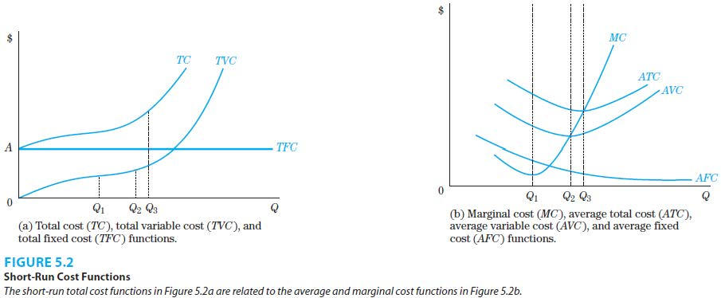

1. The marginal cost curve intersects both the average total cost and average variable cost curves at their minimum points.
2. Relationship Between Short-Run Production and Cost
3. Marginal cost and marginal product are inversely related to each other.
4. Average variable cost and average product are inversely related to each other.
5. This is illustrated in Figures 5.3a and 5.3b.

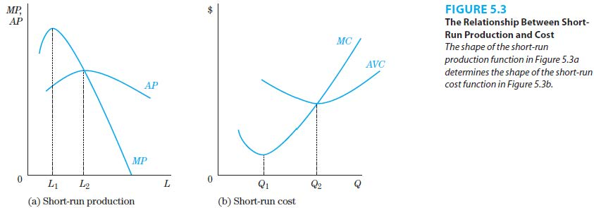

1. Other Short-Run Production and Cost Functions
2. The underlying production function determines the shapes of short-run cost curves.
3. A linear production function and its curves are illustrated in Figures 5.4a to 5.4d. In particular, marginal product and marginal cost are constant.

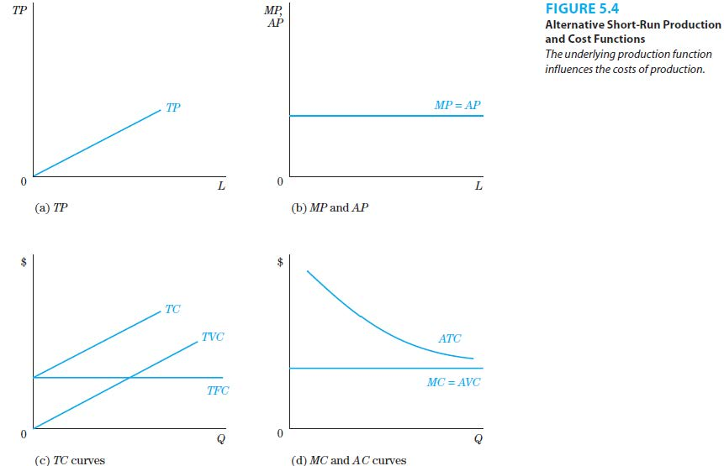

|  |
| --- |
| **References** |

Mankiw, N. Gregory. *Principles of economics*. Cengage Learning, 2018.

Farnham, P.G. 2013. *Economics for Managers*. 3rd edn. United States of America: Prentice Hall.