Topic 2: Demand

  - Demand

- Demand: Functional relationship between the price and quantity demanded of goods and services by consumers in a given period of time, all else held constant.

- Non-price factors influence demand, causing either an increase or a decrease in demand. These factors are the following.

- Tastes and Preferences

- A favorable change in the taste for good X increases its demand.

- Income

- Normal Good: A product whose demand will increase with an increase in income.
- Inferior Good: A product whose demand will decrease with an increase in income.

- Prices of Related Goods

- Substitute Goods: Products that can be used in place of one another. An increase in the price of a substitute good, Y, causes an increase in the demand for good X.
- Complementary Goods: Products that are used together. A decrease in the price of a complementary good, Y, causes an increase in the demand for good X.

    - Future Expectations

      - An expected increase in the future price of good X will increase its current demand.
      - This was demonstrated in the world grain prices in 2007 and in steel prices in 2011.

    - Number of Consumers

  - Demand Curve: The graphical relationship between the price of a good (P) and the quantity demanded by consumers (Q), with all other factors influencing demand held constant.

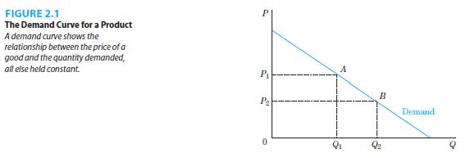

    - Demand Shifters: The variables in a demand function that are held constant when defining a given demand curve. If their values change, the demand curve would shift.

    - Price is on the vertical axis and quantity demanded is on the horizontal axis.

    - Demand curves are generally downward sloping.

    - Price and quantity demanded have a negative relationship.

  - Change in Quantity Demanded and Change in Demand

    - Change in Quantity Demanded: Movement along a demand curve when consumers react to a change in the price of the product, all other factors held constant. This is illustrated in Figure 2.1.

    - Change in Demand: Movement of the entire demand curve when consumers react to a change in factors other than the price of the product changing. This is illustrated in Figure 2.2.

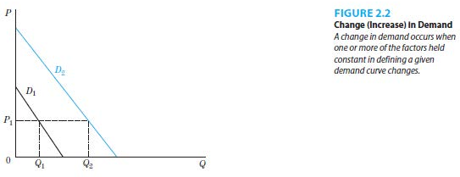

  - The market demand curve can be derived by horizontal summation of the individual demand curves.

    - Horizontal Summation: For every price, add the quantity that each individual in a market demands.
    - A simple example is when there are two individuals in a market. This is illustrated in Figure 2.3.

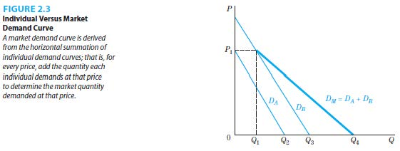

  - Linear Demand Function and Curves

    - Linear Demand Function: Mathematical relationship in which all terms are added or subtracted.

    - The graph of a linear demand curve is a straight line.

References

Mankiw, N. Gregory. Principles of economics. Cengage Learning, 2018.
Farnham, P.G. 2013. Economics for Managers. 3rd edn. United States of America: Prentice Hall.

